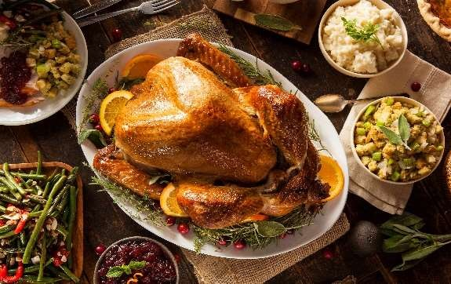

Collection Name:

Phone Number:
Email:

Christmas Pre order form 2023

Orders in by 8th December 2023
Collect from: | Costock
 | East Leake
 | Ruddington

Tuesday 19th December (8am - 2pm) Wednesday 20th December (8am - 1pm) Thursday 21st December (8am - 3pm) Friday 22nd December (8am - 6pm) Saturday 23rd December (7am -3pm)
Costock collection only Sunday 24th December (7am - 11am)

Please tick the items you require and fill in quantities as appropriate
Free Range Turkey £13.75 per KG

Traditional whole Turkey £11.40 per kg

4.5-5.6kg 4.5-5.6kg

5.6-6.5kg 5.6-6.5kg
6.6- 7.9kg 6.6- 7.9kg
8kg + 8kg +

Free Range Turkey Crown £22.90 per kg Traditional Turkey crown £19.50 per kg
on the bone on the bone

2-2.5kg 2-2.5kg
2.6 - 3.5kg 2.6 - 3.5kg
3.5 - 4.9kg 3.5 - 4.9kg
5kg + 5kg +
Free Range Turkey Butterfly £29.99 per kg Turkey Butterfly - £14.99 per kg*
Boneless Boneless
Classic Classic
kg
kg
Stuffed Stuffed
kg
kg

Christmas Day for 8 |  | Hamper for 6 |  | Christmas Dinner for 4 |  | Christmas for 2
 | £155 |  | £90 |  | £45 |  | £35
4.5-5 KG Free range turkey sausage meat (440g)  16 pigs in blankets Streaky bacon (400g) 2 Packs Stuffing 1 Bread sauce 1 Cranberry sauce Gammon joint 1.5kg Beef Joint 1.5kg  Pork Pie |  | 2kg Turkey butterfly * 6 pigs in blankets Sausage meat (440g) Streaky bacon (250g) 1 Pack Stuffing Gammon joint 1.2kg Beef roasting joint 1.2kg  1 pork pie |  | 1.2kg turkey butterfly * Sausage meat (440g) 8 x pigs in blankets 200g streaky bacon 1 cranberry sauce 1 pack stuffing 1 Bread sauce |  | 800g Turkey butterfly* Sausage meat (250g) 6 Pigs in blankets 1 Pack Stuffing 1 cranberry sauce 1 Pork pie 1 Sliced cooked ham 200g
 |  | * Boneless rolled turkey breast - maybe from UK or EU
weight are Appox

Packington Free range Chicken £8.95 per kg
Packington Free Range Cockerel £13.10 per kg

Small ~3-4kg Small ~1.4-1.7kg
Medium ~4-5kg Medium ~1.8 - 2.2kg
Large ~5-6kg Large ~2.2 - 3kg
Free Range Goose £17.99 per kg Small ~4kg
British Whole Chicken
kg |  | up to 3kg £7.40/kg
kg |  | 0ver 3kg £8.75/kg
Whole Duck £8.99 per kg
 |  | approx 2-2.5kg each

Medium ~5kg
Large ~5.5kg

Packington Pork Joints
kg
kg
kg
kg
kg

kg
kg
kg
kg

Quantity Grass Reared Beef Joints

Leg | £11.49 /kg |  | Rib of Beef | £24.75/kg
Boneless Loin | £13.49/kg |  | Rolled Sirloin | £27.99/kg
Shoulder | £10.49 /kg |  | Roasting Beef | £15.49/kg
Porchetta | £13.49/kg |  | Fillet of beef | £52.99/kg

Bacon Smoked Bacon Unsmoked
kg
kg
kg
kg

kg
kg
kg
kg

Gammon £14.30/kg Gammon £14.00/kg
Back Bacon £14.25/kg Back Bacon£13.40/kg
Streaky £14.55/kg Streaky 14.25/kg

Cooked Ham
joint £25.99/kg
Cooked Ham
joint £25.49/kg

Sausages £10.49 per kg Pork Pies quantity
kg
kg
kg
kg
kg

Plain Pork 1lb Pork pie
Lincolnshire 2lb Pork pie
Olde English 1lb with stilton
Chipolatas £10.99/kg 1lb Huntsman
Sausage meat £9.99/kg 1lb Red leicester & pickle
chipolatas and streaky bacon to make 1lb Pork & apple cider how many pigs in blankets

NB : You should receive a confirmation email within 72hrs, please contact us ASAP if you do not receive it.
Prices from suppliers are changing regularly and may change again before Christmas. We will contact you if prices change before collection, we apologise for any inconvenience this may cause.

I am paying a £20 deposit when returning this form at the butcher I am paying a £20 deposit via bacs transfer to: Mrs J S Brown
Account no. 43869105 Sort code - 20-55-68 Please use your collection name as a reference

Any comments or extra orders

Thank you very much for your order and your custom. We wish you all a very Merry Christmas Jenny & Chris and the Elms Farm Team

