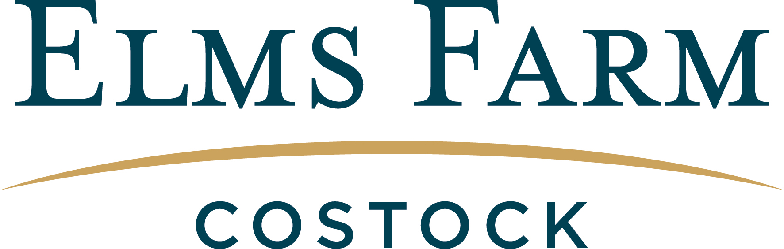

Welcome to our Elms Farm Costock Order & Collect & Delivery Service

With COVID-19 restrictions easing, we can confirm we will continue to offer a Delivery Service as well as an Order & Collect Service.

Our promise is to prepare & supply you with quality food from our trusted British farmers and suppliers.

We have selected our most popular food items in the attached order form but you also have the option of ordering more specific products that we sell in the Butchers and Farm Shop. If you would like other items, please call us on 07894 920011.

Order & Collect Service
How to order: Call us on 07894 920011 or email orders@elmsfarmcostock.co.uk

PLEASE REMEMBER TO GIVE US 24 HOURS NOTICE FOR AN ORDER.
We will acknowledge all emails within the 24-hour period.

Collection/Opening Times:

Costock: Tuesday to Friday 9am - 5pm Saturday 8am – 2pm
East Leake: Tuesday 9am - 3.30pm, Wednesday 9am - 1pm,
Thursday & Friday 9am - 5pm, Saturday 8.30am - 1.30pm
Ruddington: Tuesday 9.30am -3.30pm Wednesday 9am - 2pm
Thursday & Friday 9am - 5pm Saturday 8.30am - 2pm

Delivery Service
How to order: Complete the order form electronically or print off and email it to orders@elmsfarmcostock.co.uk. We will then email you the total for your order and you can pay by BACS before your delivery. Minimum delivery order of £25.

Our delivery schedule is as follows:
Wednesday – East Leake, West Leake , Gotham, Costock and surrounding areas
Thursday – Ruddington, Bradmore, Bunny, and surrounding areas
Friday – Wymeswold, Wysall, Willoughby, Hoton, and surrounding areas

If you would like a FREE local delivery, please email us your order at least 2 DAYS BEFORE YOUR DELIVERY DAY. So, place your order by Monday for Wednesday delivery; by Tuesday for Thursday delivery; and by Wednesday for Friday delivery.
NAME: | PHONE NO: |  | COLLECT OR DELIVERY:
ADDRESS:  Email Address: |  | PREFERRED DAY:

Product | Price £ | Quantity | Office Use
Beef Mince | 10.25 / kg
Beef Stewing Steak | 12.45 / kg
Beef Steak Burgers | 1.50 each
Roasting Beef | 14.10 / kg
Beef steaks (specify type, prices vary)
Lamb Chops | 18.10 / kg
Barnsley Chops | 17.99 / kg
Rack of Lamb | 19.15 / kg
Lamb Steaks | 18.45/ kg
Lamb Shanks | 11.25 / kg
Lamb Neck | 5.99 / kg
Lamb Mince | 10.95 / kg
Diced Lamb | 12.95 / kg
Lamb Burgers | 1.75 each
Lamb Koftas | 1.45 each
Boneless Lamb Shoulder | 12.95 / kg
Boneless Lamb Leg | 16.99 / kg
Pork Chops | 11.50 / kg
Pork Leg Steaks | 11.99 / kg
Pork Belly Strips | 9.99 / kg
Pork Ribs | 9.25 / kg
Diced Pork | 9.99 / kg
Pork Shoulder Roast | 8.99 / kg
Pork Leg Roast | 10.55 / kg
Pork Sausages (Gluten Free) | 9.70 / kg
Pork Chipolatas (Gluten Free) | 9.95 / kg
Lincolnshire Sausages | 9.70 / kg
Unsmoked Middle Bacon | 14.00 / kg
Smoked Middle Bacon | 14.25 / kg
Bacon Lardons | 10.75 / kg
Gammon Joints | 12.50 / kg
Cooked Ham | 18.99 / kg
Chicken Fillets | 14.99 / kg
Chicken Legs | 6.95 / kg
Chicken Thighs/Drumsticks | 8.99 / kg
Whole Chicken (av 2-2.5 kg) | 6.45 / kg
Free Range Eggs | 1.50 / ½ doz
Cropwell Bishop Blue Stilton | 1.65 / 100g
Cropwell Bishop Beauvale | 1.99 / 100g
Sparkenhoe Vintage Red Leicester | 1.99 / 100g
Blackstone Vintage Cheddar | 3.49 / 250g
Cheshire Butter (salted) | 2.49 / 250g
Cheshire Butter (unsalted) | 2.59 / 250g
Manor Farm Yogurts (small) | 70p each
Vine Farm Milk (bottle) | 2.75 / 1l
Vine Farm Milk (refill – return empty bot.) | 1.25 / 1l
Longley Farm Double Cream | 1.95
Findlaters Pate (specify type, prices vary) | 2.99 – 3.49
Sausage Rolls ( Frozen Raw) | 1.49 each
Yorkshire Pasties (Frozen Raw) | 1.99 each
Original Baker Steak & Ale Pie (4 pers) | 11.50 each
Chicken, Bacon & Mushroom Pie (4 pers) | 11.50 each
Bread (prices vary, specify preference)
Cake (prices vary, specify preference)
Jam (prices vary, specify preference)
Sauces (prices vary, specify preference)
ANY SPECIAL REQUESTS

PLEASE NOTE THAT SUBSTITUTIONS WILL BE MADE ON MEAT ORDERS WHEN YOUR FIRST CHOICE IS NOT AVAILABLE. THERE MAY BE SOME PRODUCTS THAT SELL OUT OR ARE IN LIMITED SUPPLY. PLEASE BEAR WITH US DURING THIS DIFFICULT TIME.

Elms Farm Costock, Leake Road, Costock, Loughborough, LE12 6XA
www.elmsfarmcostock.co.uk | orders@elmsfarmcostock.co.uk
07894 920011

